**MIND STORM SOFTWARE PVT LTD**

**Hands-On Exercise – ex04.doc**

**Objective**This exercise shows how to use built in Intents in Android. It means that when we have to perform common operations like dial a phone number, send a SMS, send an email, view a web url in a browser, then there are already existing applications on the Android device that can do it for us. All we need to do then is to specify our intent (what we want to do) and Android will choose the right program and launch it.

**Assumptions**

* Development Environment for Android (Java SDK, Eclipse, Android SDK) has been setup successfully.
* You are familiar with using Eclipse.
* Android SDK 2.3.3 is available and Android Virtual Devices are already created.
* Start the Android Virtual Device to save time.
  + Click on **Window 🡪 Android SDK and AVD Manager**.
  + Select an **Android 2.3.3** compatible AVD and click on **Start**
  + Select **Scale display to real size** and provide a **Screen Size (in)** as **5 inches** or any other appropriate size for your development machine.

**Step by Step Instructions**

**Step 1 – Create the Android Project**

1. Create a new project. Click on **File🡪New 🡪 Android Project**
2. Enter **Project Name** as **ex04 .**Click on **Next.**
3. Select the **Build Target** as **Android 2.3.3 .**Click on **Next.**
4. Enter **Package Name** as **com.mindstorm.ex04**
5. In **Create Activity**, overwrite the default Activity name with the following name : **MainActivity**
6. Click on **Finish**
7. (Optional): Verify that the Project runs in your Emulator by **Right-click** the **Project** and **Run As 🡪 Android Application**

**Step 2 – Code the Main Activity**

1. Define the Layout for Main Activity. This will consist of a few buttons which will launch the different applications which correspond to the Intent.

Go to **res/layout** folder. Modify **main.xml** to contain the following (You can simply copy this).

<?xml version=*"1.0"* encoding=*"utf-8"*?>

<LinearLayout xmlns:android=*"http://schemas.android.com/apk/res/android"*

android:orientation=*"vertical"*

android:layout_width=*"fill_parent"*

android:layout_height=*"fill_parent"*

>

<TextView android:text=*"Built In Intents"* android:gravity=*"center_horizontal"* android:id=*"@+id/textView1"* android:textAppearance=*"?android:attr/textAppearanceLarge"* android:layout_width=*"fill_parent"* android:layout_height=*"wrap_content"*></TextView>

<Button

android:id=*"@+id/btn_makecalls1"*

android:layout_width=*"fill_parent"*

android:layout_height=*"wrap_content"*

android:text=*"Action Dial"* />

<Button

android:id=*"@+id/btn_makecalls2"*

android:layout_width=*"fill_parent"*

android:layout_height=*"wrap_content"*

android:text=*"Action Call"* />

<Button

android:id=*"@+id/btn_sendsms"*

android:layout_width=*"fill_parent"*

android:layout_height=*"wrap_content"*

android:text=*"Send SMS"* />

<Button

android:id=*"@+id/btn_sendemail"*

android:layout_width=*"fill_parent"*

android:layout_height=*"wrap_content"*

android:text=*"Send Email"*/>

</LinearLayout>

1. Go to **src** 🡪 **com.mindstorm.ex04** and open **MainActivity.java** file. Modify the MainActivity.java code as shown below:

**package** com.mindstorm.ex04;

**import** android.app.Activity;

**import** android.content.Intent;

**import** android.net.Uri;

**import** android.os.Bundle;

**import** android.view.View;

**import** android.view.View.OnClickListener;

**import** android.widget.Button;

**public** **class** MainActivity **extends** Activity {

Button b1, b2, b3, b4;

/** Called when the activity is first created. */

@Override

**public** **void** onCreate(Bundle savedInstanceState) {

**super**.onCreate(savedInstanceState);

setContentView(R.layout.*main*);

//---Action Dial button---

b1 = (Button) findViewById(R.id.*btn_makecalls1*);

b1.setOnClickListener(**new** OnClickListener()

{

**public** **void** onClick(View arg0){

Intent i = **new** Intent(android.content.Intent.*ACTION_DIAL*,Uri.*parse*("tel:+651234567"));

startActivity(i);

}

});

//---Action Call button

b2 = (Button) findViewById(R.id.*btn_makecalls2*);

b2.setOnClickListener(**new** OnClickListener()

{

**public** **void** onClick(View arg0){

Intent i = **new** Intent(android.content.Intent.*ACTION_CALL*,Uri.*parse*("tel:+651234567"));

startActivity(i);

}

});

//---Send SMS button

b3 = (Button) findViewById(R.id.*btn_sendsms*);

b3.setOnClickListener(**new** OnClickListener()

{

**public** **void** onClick(View arg0){

Intent i = **new** Intent(android.content.Intent.*ACTION_VIEW*);

i.putExtra("address", "9820300784;9821060381");

i.putExtra("sms_body", "Hi. I am currently attending the Android Workshop.");

i.setType("vnd.android-dir/mms-sms");

startActivity(i);

}

});

//---Send Email button

b4 = (Button) findViewById(R.id.*btn_sendemail*);

b4.setOnClickListener(**new** OnClickListener()

{

**public** **void** onClick(View arg0){

Intent emailIntent = **new** Intent(Intent.*ACTION_SEND*);

String[] to = {"romin.k.irani@gmail.com","romin.irani@mindstormsoftware.com"};

emailIntent.putExtra(Intent.*EXTRA_EMAIL*, to);

//String[] cc = carbonCopies;

//emailIntent.putExtra(Intent.EXTRA_CC, cc);

emailIntent.putExtra(Intent.*EXTRA_SUBJECT*, "Reminder For Android Workshop");

emailIntent.setType("text/plain");

emailIntent.putExtra(Intent.*EXTRA_TEXT*, "Please note that the Android Workshop is going to be held on 6th October 2012.");

startActivity(Intent.*createChooser*(emailIntent, "Send Email via..."));

}

});

}

}

**Step 3 – Add the Permission in Manifest**

Go to the **AndroidManifest.xml** file and add the following permission. This is needed when you use the **ACTION_CALL**. Add this element as a child of the **<manifest>** element and outside of the **<application>** element.

<uses-permission android:name="android.permission.CALL_PHONE"></uses-permission>

**Step 4 – Run the Example**

1. **Right Click** the **Project** in Eclipse.
2. Select **Run As 🡪 Android** Application
3. (Optional): If you have multiple compatible AVDs running, select the correct AVD. In our case it is the 2.3.3 AVD.

You should see the MainActivity screen come up.

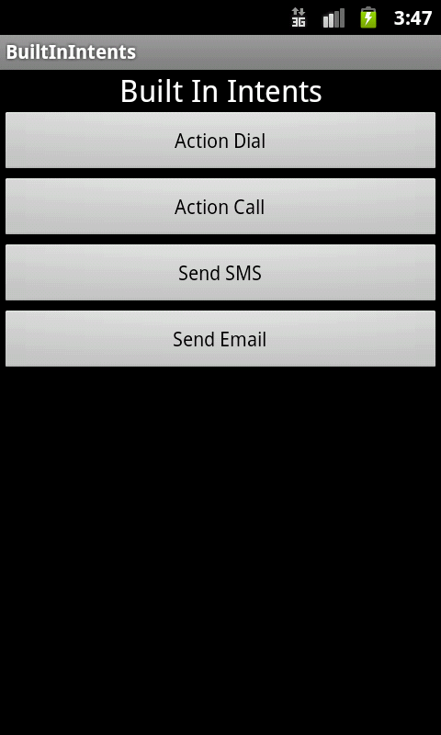

Clicking on any of the buttons will result in the application specifying an Intent where it only specifies the Intent Action along with data. For e.g. if you click the Make Calls button, it will launch the Call Application as shown below:

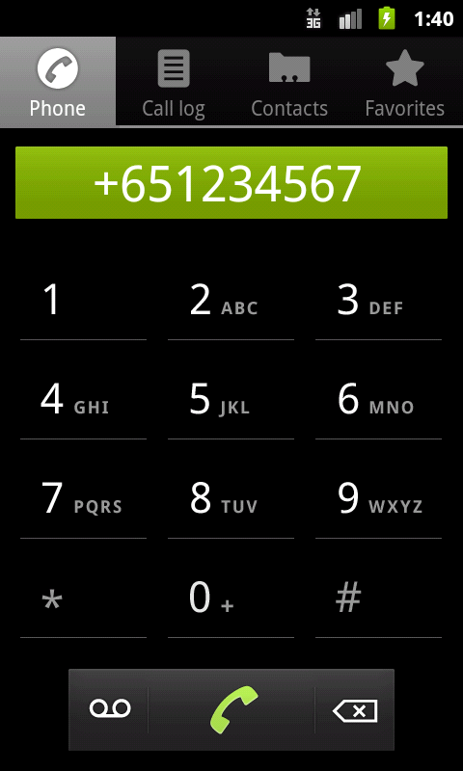

**Summary**

This hands-on exercise demonstrated how to use Built-In Intents in Android. We learnt about the following built-in intents in Android:

* android.content.Intent.ACTION_DIAL
* android.content.Intent.ACTION_CALL
* android.content.Intent.ACTION_VIEW
* android.content.Intent.ACTION_SEND

More Reference:

1. For built in Intents of Google Applications : <http://developer.android.com/guide/appendix/g-app-intents.html>
2. For more Actions available in Android : <http://developer.android.com/guide/topics/intents/intents-filters.html>